**JAVA PROGRAM:**

* **Introduction:**

Java is a popular programming language, created in 1995. It is owned by Oracle, and more than 3 billion devices run Java. It is used for: Mobile applications (specially Android apps).

**METHOD:**

A method is **a block of code which only runs when it is called**. You can pass data, known as parameters, into a method. Methods are used to perform certain actions, and they are also known as functions.

**OBJECT:**

A Java object is a member (also called an instance) of a Java class. Each object has an identity, a behavior and a state. The state of an object is stored in fields (variables), while methods (functions) display the object's behavior. Objects are created at runtime from templates, which are also known as classes.

For example: in real life, a car is an object. The car has attributes, such as weight and color, and methods, such as drive and brake.

**INHERITANCE:**

Inheritance in Java is **a concept that acquires the properties from one class to other classes**; for example, the relationship between father and son. Inheritance in Java is a process of acquiring all the behaviours of a parent object.

For example, **a child inherits the traits of his/her parents**. With inheritance, we can reuse the fields and methods of the existing class.

**ABSTRACTION:**

Hiding the data.

EX:Atm

**ENCAPSLATION:**

Wrapinng up of the data into a single unit.

EX: capsales tablets

**1.Main code:**

**Electricity bill in online:**

package sample;

import java.util.Scanner;

public class electricitybillonline {

public static void main(String[] args) {

String name;

int mobile=970497;

int bill=500;

Scanner scanner=new Scanner(System.in);

System.out.println("enter mobile number");

int otp=scanner.nextInt();

if(otp==mobile)

{

System.out.println("enter your name");

name=scanner.next();

System.out.println("good morning"+name);

while(true)

{

System.out.println("enter your name");

int payment = 0;

switch(payment) {

case 1:

System.out.println("enter your mobile numebr");

break;

case 2:

System.out.println(" you can pay through phonepay");

int ShowAmount = scanner.nextInt();

System.out.println(" you have sufficient money to pay you can pay now");

break;

case 3:

System.out.println(" how much amount did you wnat to send");

int SendAmount = scanner.nextInt();

int balance = 0;

if(SendAmount>balance)

{

System.out.println(" if you are giving wrong password and otp");

}

else

{

System.out.println(" if you are giving correct number and otp it will pay");

break;

}

Object submit = null;

Object completed = null;

if(submit==completed)

{

System.out.println("thank you");

}

}

}

}

else {

System.out.println("wrong otp");

}

}

}

Output:

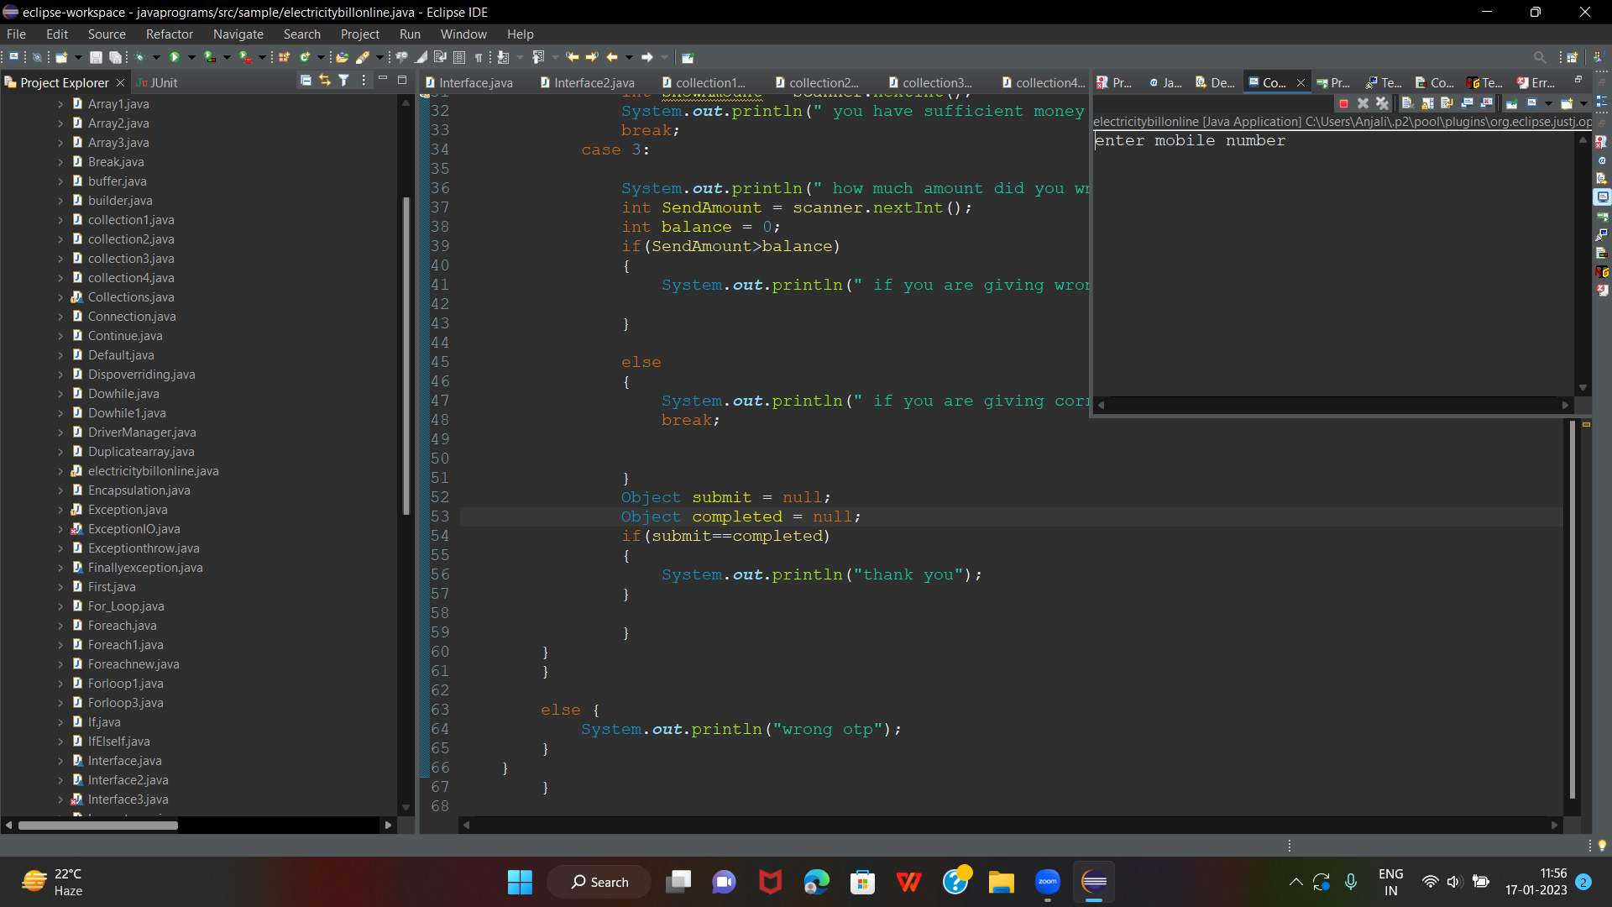

**2.Collections:**

package sample;

import java.util.*;

public class collection1{

public static void main(String[] args) {

Deque<String> deque = new ArrayDeque<String>();

deque.add("hii");

deque.add("all");

deque.add("good morning");

for (String st : deque) {

System.out.println(st);

HashSet<String> set=new HashSet<String>();

set.add("39");

set.add("65");

set.add("65");

set.add("39");

Iterator<String> itr=set.iterator();

while(itr.hasNext()){

System.out.println(itr.next());

List<String> list=new ArrayList<String>();

list.add("M");

list.add("A");

list.add("B");

list.add("G");

for(String letters:list)

System.out.println(letters);

}

}

}

}

Output:

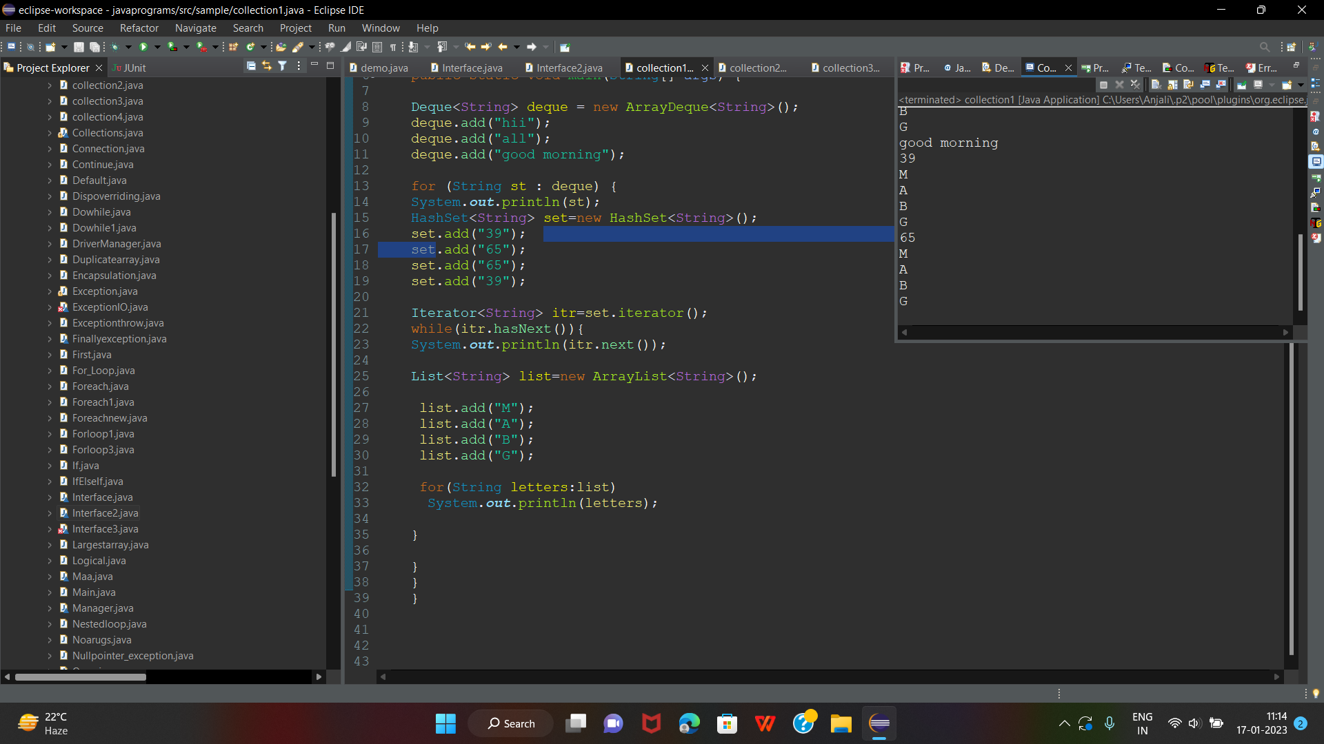

**3.Interfaces:**

package sample;

interface salary{

void monthly();

}

class emp implements salary{

public void monthly(){

System.out.println("emp wants salary");

}

}

class Interface

{

public static void main(String args[]){

emp obj = new emp();

obj.monthly();

}

}

/*interface mother{

void love();

}

interface children{

void love();

}

class Interface2 implements mother, children{

public void love()

{

System.out.println("mothers love is unconditional");

}

public static void main(String args[])

{

Interface2 ob1 = new Interface2();

ob1.love();

}

} */

OUTPUT:

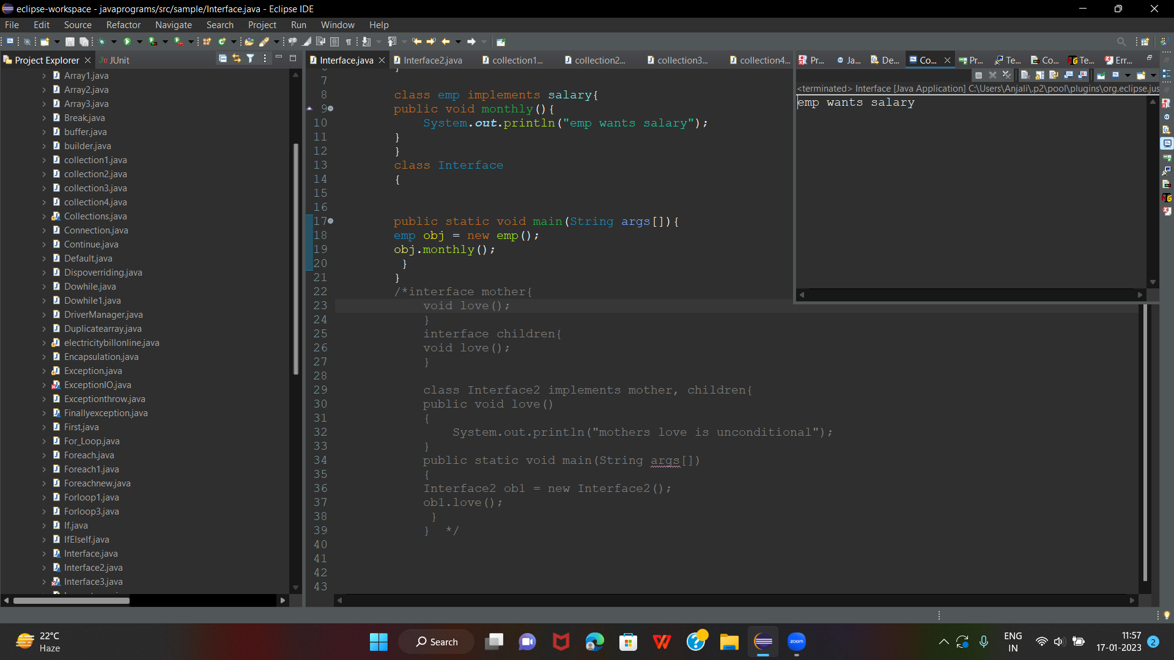

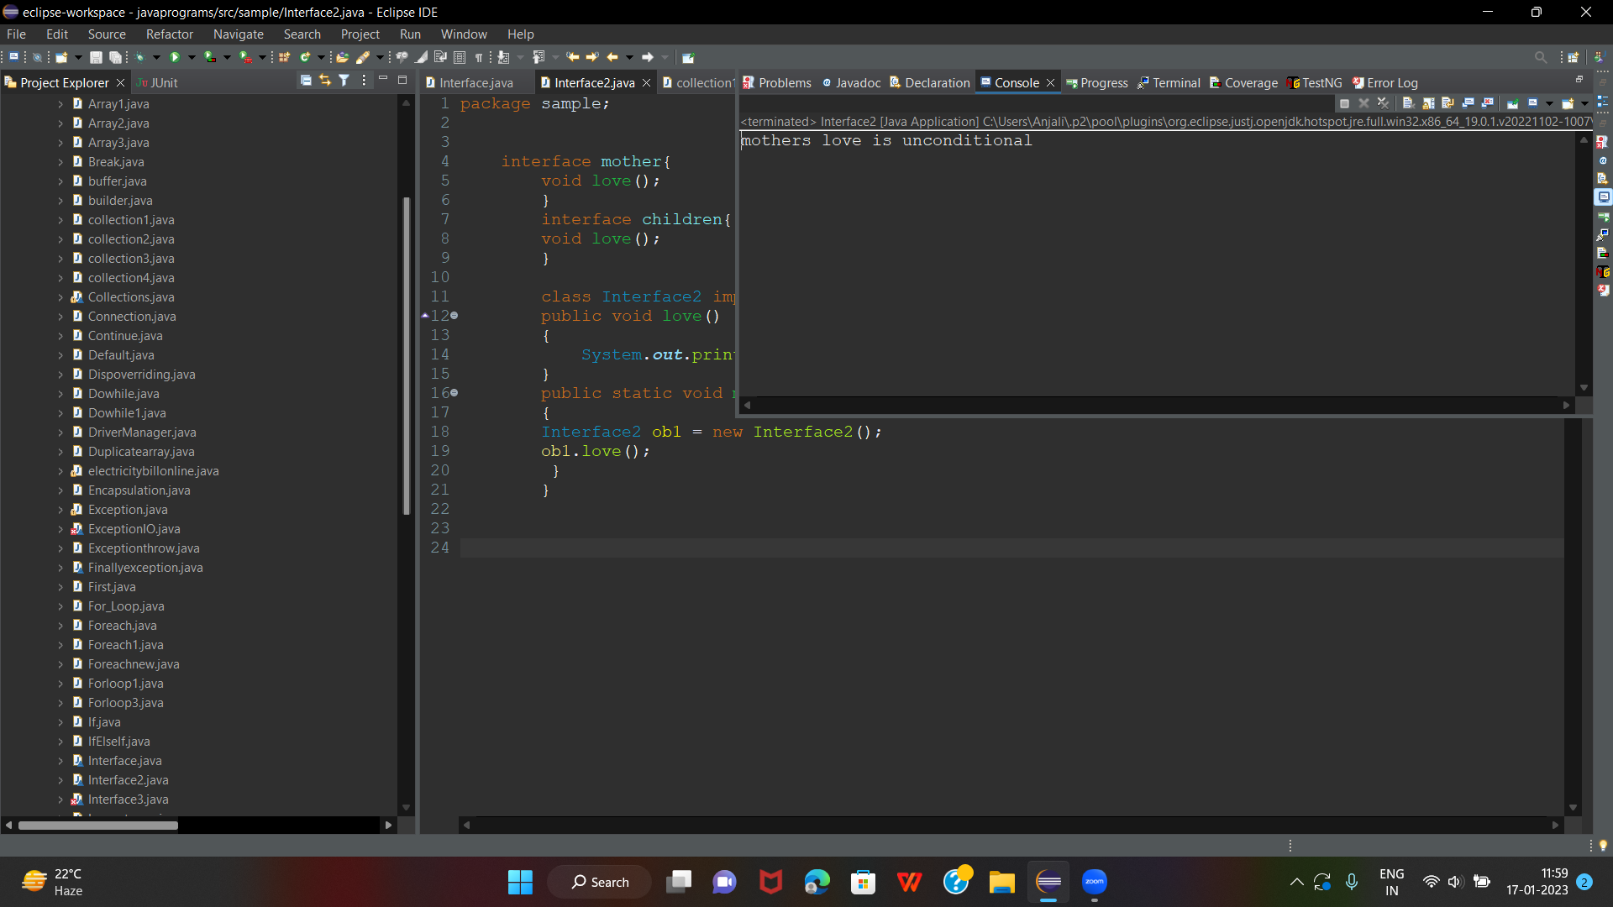

**4.OverLoading:**

package sample;

class poly1 {

public void data(int num,int num1)

{

System.out.println("add numbers:"+(num+num1));

}

public void data(int num,double d)

{

System.out.println("add numbers:"+(num+d));

}

}

class Overloading2

{

public static void main(String args[])

{

poly1 ob2=new poly1();

ob2.data(10,20);

ob2.data(23,5.7);

}

}

/*class poly {

public void seq(int num, char c)

{

System.out.println("display the number and charcter:");

}

public void seq(char c,int num)

{

System.out.println("display the charcter and number");

}

}

class Overloading1

{

public static void main(String args[])

{

poly ob2=new poly();

ob2.seq(10,'a');

ob2.seq('b',20);

}

}*/

OUTPUT:

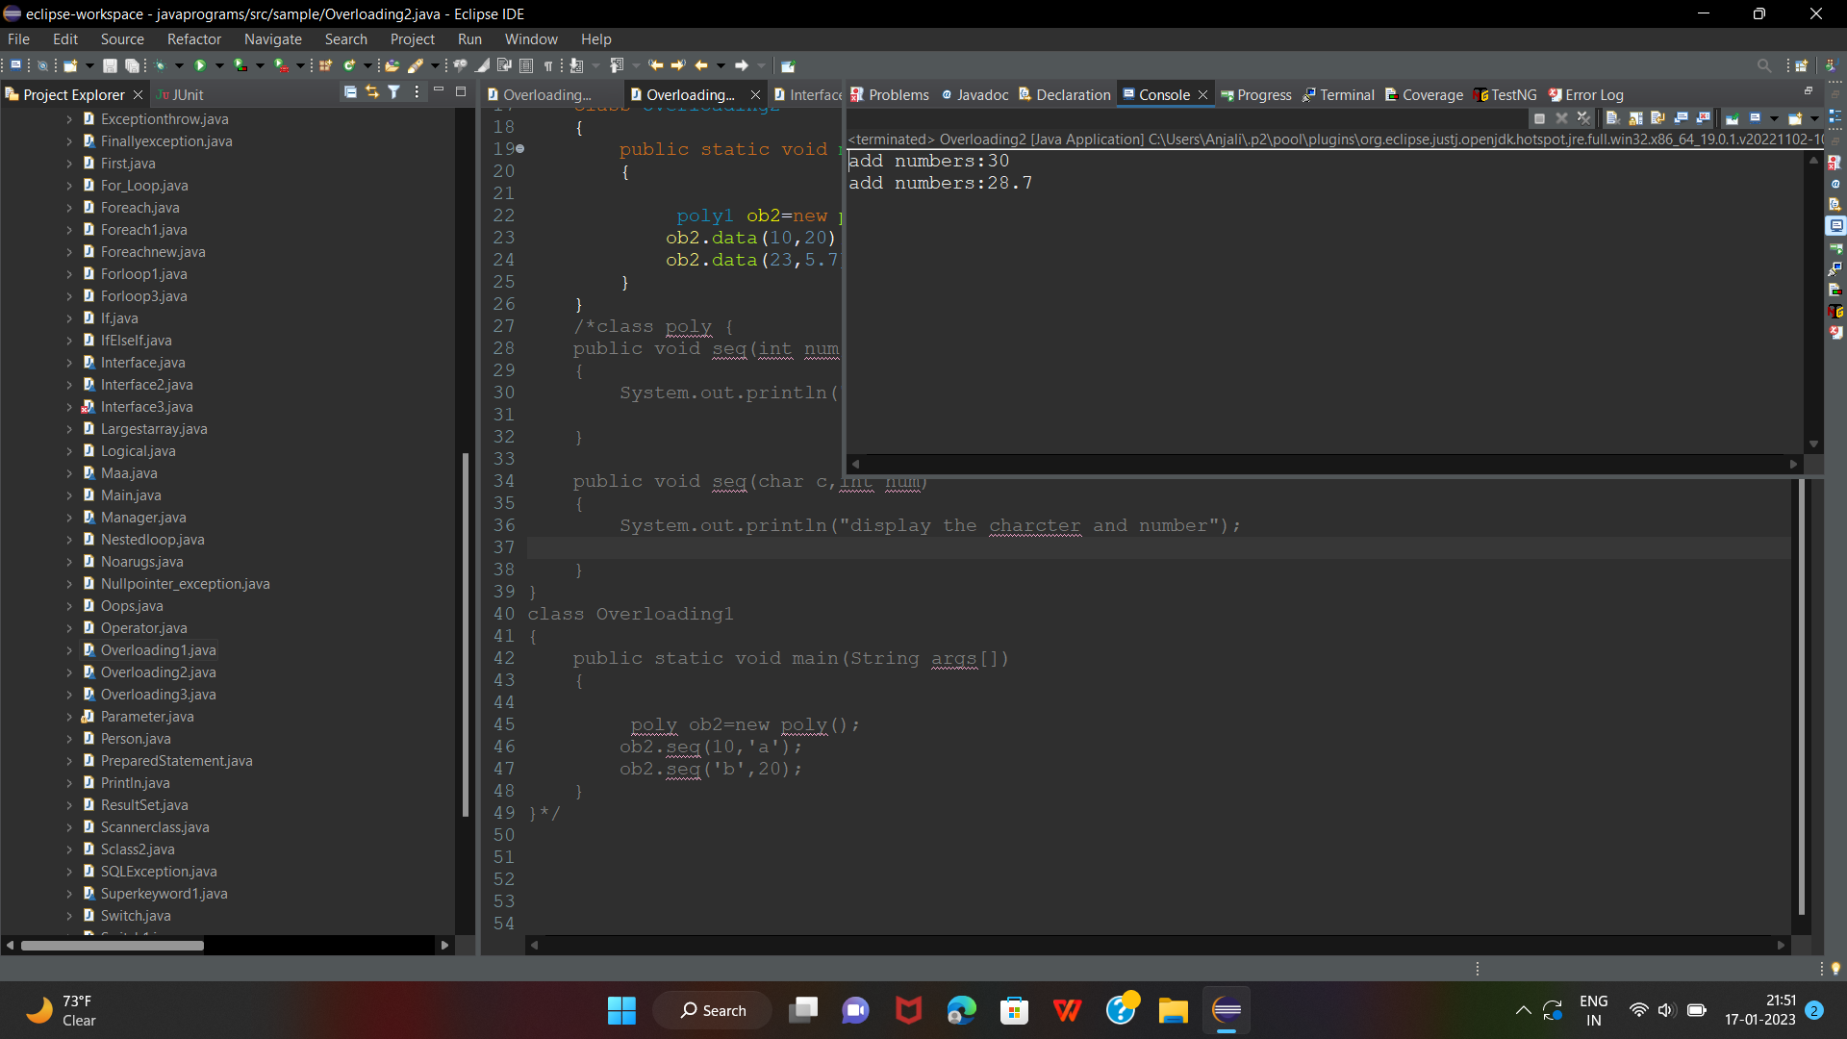

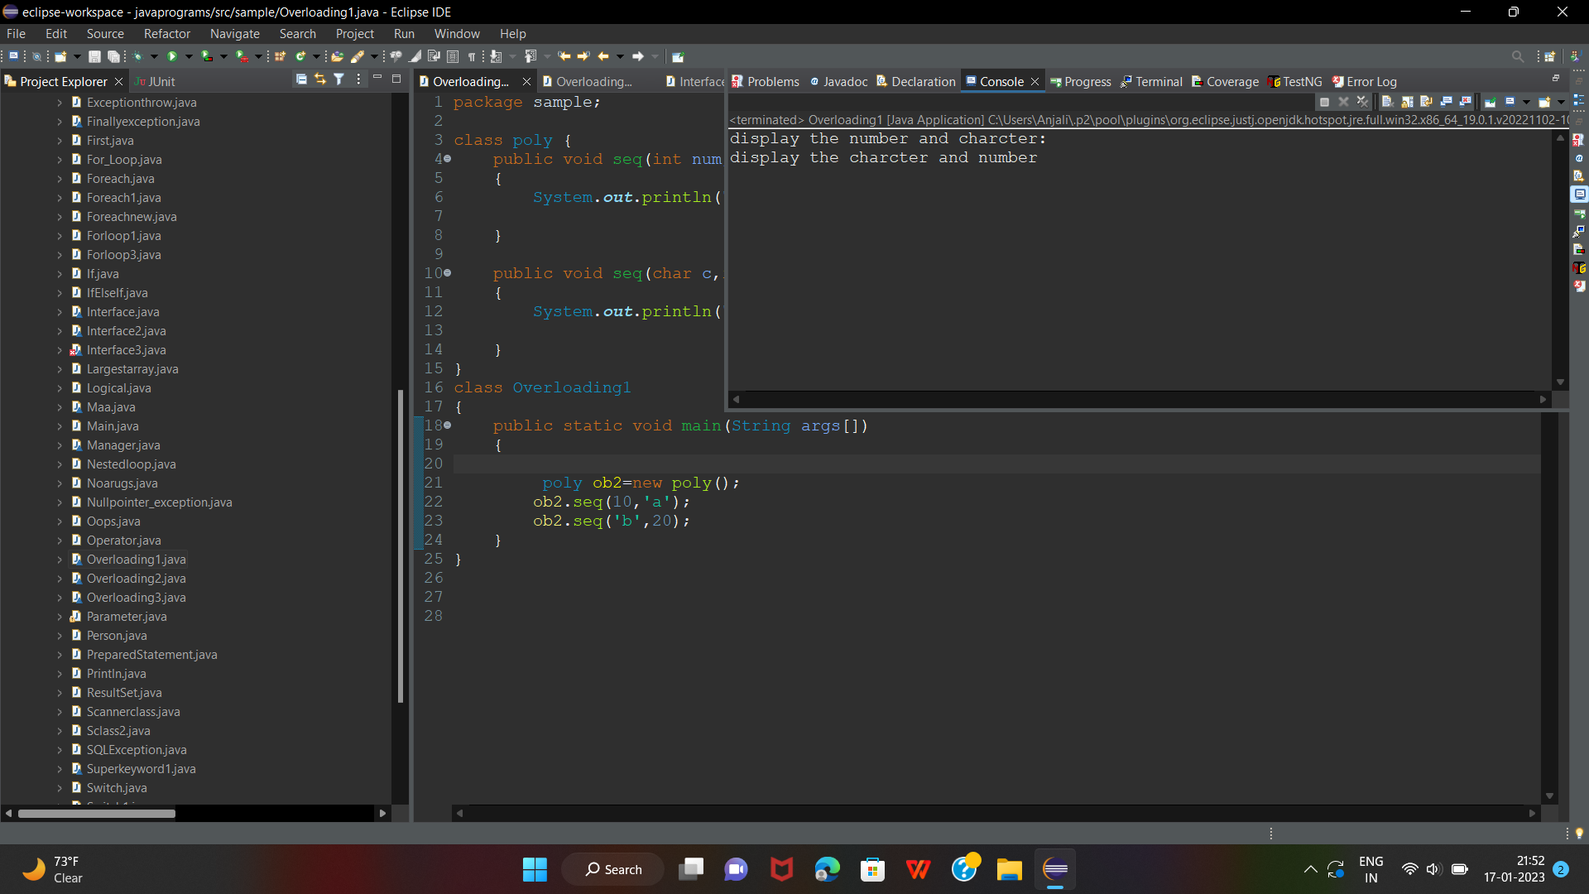

**5.JAVA CALENDER:**

**CODE:**

package sample;

public class Foreachnew {

public static void main(String[] args)

{

String[] mon= {"January"};

String[] day= {"Monday","Tuseday","Wednesday","Thursday","Friday"

,"Saturday","Sunday"};

for(int i=0;i<=1;i++)

{

System.***out***.println("Month:" +mon[i]);

for(int j=1;j<=4;j++) {

System.***out***.println("week:" + j);

for(String D : day) {

System.***out***.println(D);

}

}

}

}  
}

**OUTPUT:**

Month:january

week:1

Monday

Tuseday

Wednesday

Thursday

Friday

Saturday

Sunday

week:2

Monday

Tuseday

Wednesday

Thursday

Friday

Saturday

Sunday

week:3

Monday

Tuseday

Wednesday

Thursday

Friday

Saturday

Sunday

week:4

Monday

Tuseday

Wednesday

Thursday

Friday

Saturday

Sunday

}

}

}